Flying Angels
YMCA Indian Programs – 1st Year Tribe

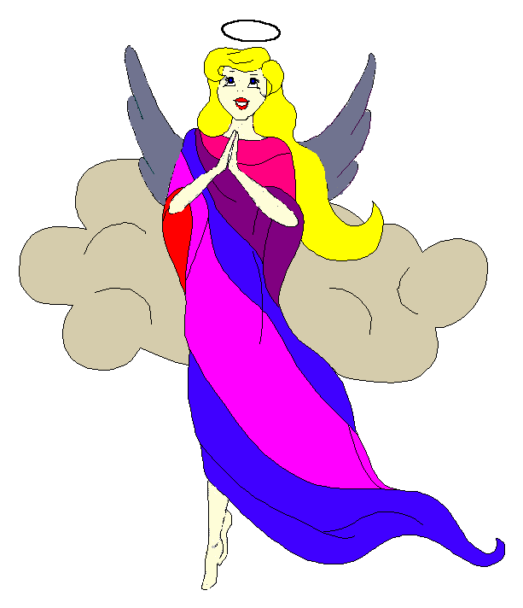
Pow-Wow Date: Tuesday, January 6, 2004

Tribe Members Present
Little Princesses Big Braves
Janie, Little Cub Lee Gray Wolf
Joanna, Rainbow Dear Randy, Roaring Thunder
Logan, Running Reindeer Grant, Gray Fox, Chief
Christine, Little Bird Rob, Early Bird, Wampum Bearer
Kimberly, Rainbow Pony Lee, Soaring Eagle
Alison, Purring Cat Steve, Barking Dog
Haley, Gray Bunny Keith, Injun Mo, Tally Keeper
Emily, Crafty Kitten Darren, Hunting Dog
Alexis, Little Acorn Ed, Tall Oak, Sachem
Pippa, Fast White Pony Jay, Black Hawk

Opening
At the time of great darkness under a cold clear sky with a full moon, the very energetic Flying Angels were welcomed into the teepee of Crafty Kitten and Hunting Dog. This was a special meeting for the tribe because it was blessed with two new members, Fast White Pony and Black Hawk. These two members will definitely help to strengthen the tribe. The fifth meeting of the Flying Angels was opened when Crafty Kitten gave 12 hammering beats of the tribal tom-tom.

The tribe was a little rusty after such a long absence for the holidays but quickly remembered how to form the unbroken circle and chanted the aims, pledge, and slogan lead by our fearless Chief. Injun Mo then read the minutes from the December 9th Pow-Wow.

Wampum Earning ($9):
All princesses clearly and loudly introduced themselves and the big braves. Then each princess announced her efforts that earned wampum for the tribe.

Feather Earning:
- Gray Bunny courageously tried to recite the tribe names but got stumped on the first name. She will try again at a later Pow-Wow.
- Little Cub flawlessly recited the 6 aims and earned a blue feather.
- Joanna very boldly decided to try the 6 aims and after a lot of concentration was successful and she too earned a blue feather.
- Little Acorn was also feeling very brave and attempted the pledge, but was also stumped. She too will try again at a later Pow-Wow.
Gray Bunny distributed red crow beads to all the tribe and bear claws were also given to any tribal members that missed the last meeting.

Meeting Activities:
- Craft | The princesses made and decorated book marks that can be used in their favorite books at home. The book marks were provided by Crafty Kitten and Hunting Dog. While the princesses completed the bookmarks, the big braves discussed and finalized plans for the upcoming winter inning at Meymandi Concert Hall.
- Snack | Crafty Kitten and Hunting Dog provided tasty cookies, popcorn, and juice for all of the tribe to enjoy.

- Song | None
- Story | Roaring Thunder told a story about an invisible Indian brave named Strong Wind. All Indian Princesses wanted to marry the brave, but only the princess that was honest and kind won the brave’s heart. The mean and dishonest princesses were eventually turned into aspen trees by the Indian Brave. This taught all the little princesses that honesty and kindness is always the best answer in any situation.
- Trick | Barking Dog performed puzzling tricks with looping nails and horseshoes and then dared the princesses to repeat his performance. None were able to perform such a fete. Barking Dog also dazzled the tribe sitting a quarter on top of a car balanced on his finger. He then thumped the card to the floor and the quarter remained on his finger. This surprised the entire tribe.
- Discussions | None

Closing:
All Flying Angels then stood in a circle and the closing prayer was led by the mighty Chief Gray Fox. The Flying Angels then fluttered away into the night until the next Pow-Wow to be held at the Tee Pee of Purring Cat and Barking Dog on the 20th day in the Month of snow and ice.

So went the Fourth meeting of the Flying Angels as reported by Injun Mo, Tallykeeper.

