Flying Angels
YMCA Indian Programs – 1st Year Tribe

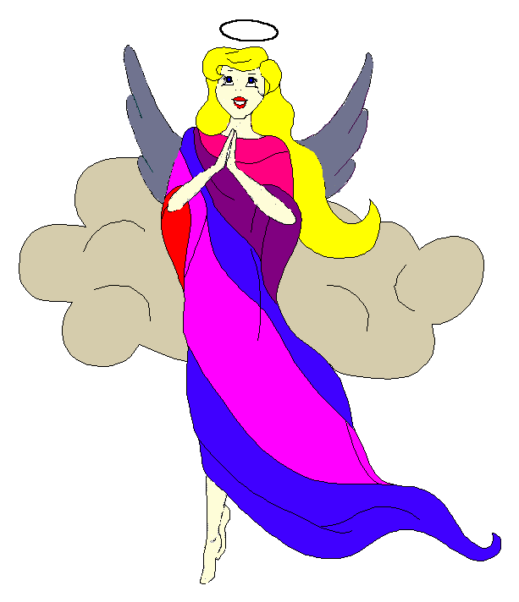
Pow-Wow Date: Tuesday, January 20, 2004

Tribe Members Present
Little Princesses Big Braves
Jamie, Little Cub Lee, Gray Wolf
Logan, Running Reindeer Grant, Gray Fox, Chief
Christine, Little Bird Rob, Early Bird, Wampum Bearer
Kimberly, Rainbow Pony Lee, Soaring Eagle
Alison, Purring Cat Steve, Barking Dog
Haley, Gray Bunny Keith, Injun Mo, Tally Keeper
Emily, Crafty Kitten Darren, Hunting Dog
Alexis, Little Acorn Ed, Tall Oak, Sachem
Pippa, Fast White Pony Jay, Black Hawk

Opening
At the time of great darkness under a very cold cloudy sky, the very eager and bouncy Flying Angels were welcomed into the teepee of Purring Cat and Barking Dog. The sixth meeting of the Flying Angels was kicked off when Purring Cat gave 12 musical beats of the tribal tom-tom.

The tribe then formed the unbroken circle and chanted the aims, pledge, and slogan lead by our fearless Chief.

Wampum Earning ($8):
All princesses clearly and loudly introduced themselves and the big braves. Then each princess announced her efforts that earned wampum for the tribe.

Injun Mo then read the minutes from the January 6th Pow-Wow to the very attentive tribe.

Feather Earning:
- Gray Bunny, Little Bird, Little Acorn, and Crafty Kitten all clearly and in loud voices recited the pledge, and for their bravery they all earned turquoise feathers.
- Little Cub and Gray Wolf prepared a special spaghetti dinner for Mrs. Wolf. The spaghetti dinner came complete with brownies and they did all the shopping, cooking and cleaning. For this Little Cub and Gray Wolf both earned yellow feathers.

Meeting Activities:
- Craft | The princesses made arm bands with beads provided by Purring Cat and Barking Dog. While the princesses worked on this project, the big braves finalized plans and issued tickets for the upcoming winter inning and circus.
- Snack | Purring Cat and Barking Dog provided frozen grapes, popcorn, Fig Newtons, and double stuffed peanut butter and chocolate cream Oreos for all the tribe to enjoy.
- Song | Little Bird and Early Bird led the tribe in Bingo where the tribe clapped to replace the left out letters.
- Story | None

- Trick | Soaring Eagle passed out twisted paper that was taped together at the ends and asked the princesses to cut it along the middle to see what shapes would be revealed. The princesses learned that they soon had one large circle that was taped at both ends. They were then asked to cut the paper down the middle one more time and they found that they had two circles looped together. Soaring Eagle just couldn’t stop with one trick so he passed out a rope and asked the princesses to hold both ends and try to tie the rope in a not. No one was able to do it so Rainbow Pony showed us that if you first fold your arms and pick up the rope that it could then be pulled into a not. It was then that we learned that Soaring Eagle has a love for magic because he had even more tricks for the tribe to enjoy. He continued with wrapping his wrists in a chain and showing the tribe how he could quickly free himself with little effort. We never knew we had such a skilled magician in the tribe.
- Discussions | None

Gray Bunny then distributed red crow beads to all the tribe.

Closing:
All Flying Angels then stood in a circle and the closing prayer was led by the mighty Chief Gray Fox. The Flying Angels then fluttered away into the night until the next Pow-Wow to be held at the Tee Pee of Tall Oak and Little Acorn on the 3rd day in the Month of more snow and ice.

So went the sixth meeting of the Flying Angels as reported by Injun Mo, Tallykeeper.

