Flying Angels
YMCA Indian Programs – 1st Year Tribe

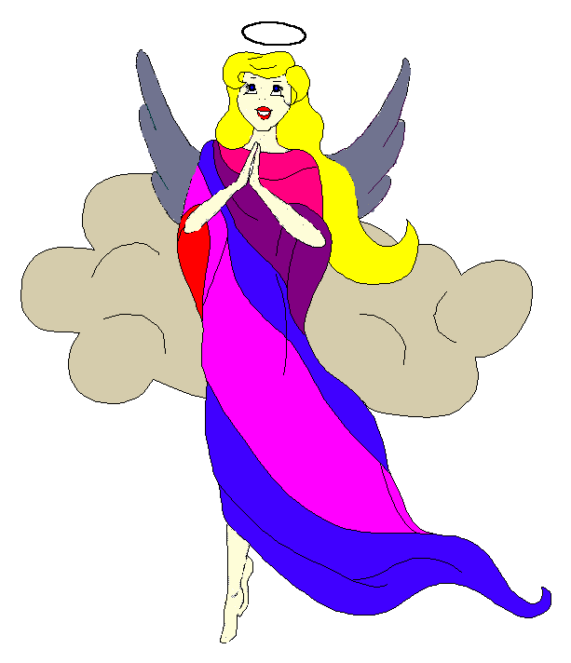
Pow-Wow Date: Tuesday, February 3, 2004

Tribe Members Present
Little Princesses Big Braves
Janie, Little Cub Lee, Gray Wolf
Logan, Running Reindeer Grant, Gray Fox, Chief
Christine, Little Bird Rob, Early Bird, Wampum Bearer
Kimberly, Rainbow Pony Lee, Soaring Eagle
Alison, Purring Cat Steve, Barking Dog
Haley, Gray Bunny Keith, Injun Mo, Tally Keeper
Emily, Crafty Kitten Darren, Hunting Dog
Alexis, Little Acorn Ed, Tall Oak, Sachem
Pippa, Fast White Pony Jay, Black Hawk

Opening
At the time of great darkness under a very cold clear sky, the very excited and enthusiastic Flying Angels were welcomed into the teepee of Little Acorn and Tall Oak. The seventh meeting of the Flying Angels was kicked off when Little Acorn gave 12 thumping beats of the tribal plastic bowl.

The tribe then formed the unbroken circle and chanted the aims, pledge, and slogan led by our fearless Chief.

Wampum Earning ($7):
All princesses clearly and loudly introduced themselves and the big braves. Then each princess announced her efforts that earned wampum for the tribe.

Injun Mo then read the minutes from the January 20th Pow-Wow to the very attentive tribe.

Feather Earning:
- Rainbow Pony very courageously recited the 6 aims and earned a blue feather.
- Fast White Pony and Black Hawk prepared a special dinner for Mrs. Hawk. For this they both earned yellow feathers.
- Gray Fox and Running Reindeer prepared an enchilada dinner for Mrs. Reindeer and both also earned yellow feathers.
- Running Reindeer then recited the pledge and earned a turquoise feather.

Meeting Activities:
- Craft | The princesses made door hangers and decorated them with letters and flowers. All materials for this craft were provided by Little Acorn and Tall Oak. While the princesses worked on this project, the big braves discussed plans for the circus, polar bear swim and spring outing.
- Snack | Little Acorn and Tall Oak provided delicious valentine cookies, pretzels and chips for all the princesses to enjoy. For the big braves, however, it was cheese and crackers, and coke prepared by Tall Oak himself.
- Song | Crafty Kitten and Hunting Dog led the tribe in the very popular “If Your Happy and You Know It”. This could be the loudest the princesses have ever been for any song the tribe has sung yet.
- Story | None

- Trick | Our mighty chief Gray Fox demonstrated mixing baking soda and vinegar in water to form carbon monoxide bubbles. If spaghetti pieces are added to the water the bubbles will make the pieces float up and down as if they are dancing…hence the trick is know as “Dancing Spaghetti”.
- Discussions | None

Gray Bunny and Injun Mo forgot to distribute the red crow beads so it will be done at the next meeting.

Closing:
All Flying Angels then stood in a circle and the closing prayer was led by the mighty Chief Gray Fox. The Flying Angels then fluttered away into the night until the next Pow-Wow to be held at the Tee Pee of Gray Bunny and Injun Mo on the 17th day in the Month of more snow and ice.

So went the seventh meeting of the Flying Angels as reported by Injun Mo, Tallykeeper.

