Flying Angels
YMCA Indian Programs – 1st Year Tribe

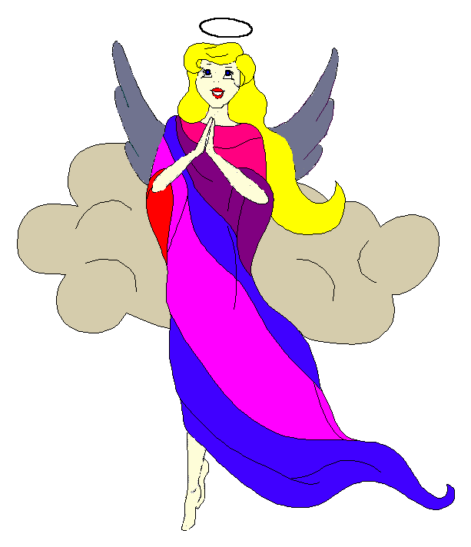
Pow-Wow Date: Tuesday, March 16, 2004

Tribe Members Present
Little Princesses Big Braves
Jamie, Little Cub Lee, Gray Wolf
Logan, Running Reindeer Grant, Gray Fox, Chief
Christine, Little Bird Rob, Early Bird, Wampum Bearer
Kimberly, Rainbow Pony Lee, Soaring Eagle
Alison, Purring Cat Steve, Barking Dog
Haley, Gray Bunny Keith, Injun Mo, Tally Keeper
Emily, Crafty Kitten Darren, Hunting Dog
Pippa, Fast White Pony Jay, Black Hawk
Alexis, Little Acorn Ed, Tall Oak, Sachem
Joanna, Rainbow Dear Randy, Roaring Thunder

Opening
At the time of great darkness under a cool clear sky, the very eager Flying Angels were welcomed into the teepee of Fast White Pony and Black Hawk. The ninth meeting of the Flying Angels was kicked off when Fast White Pony 12 pounding beats of the tribal tom-tom.

The tribe then formed the unbroken circle and chanted the aims, pledge, and slogan led by our fearless Chief.

Wampum Earning ($10):
All princesses clearly and loudly introduced themselves and the big braves. Then each princess announced her efforts that earned wampum for the tribe. Then Injun Mo read the minutes from the February 17th Pow-Wow to the very attentive tribe.

Feather Earning:
- Running Reindeer very bravely recited the six aims and earned a blue feather.
- Little Cub very impressively repeated all the real and tribal name of every big brave and little princes. For this she earned a red feather. Little Cub was the first in the tribe to earn this feather.
- Crafty Kitten and Hunting Dog prepared a great dinner for Mrs. Dog (Mrs. Mo wasn’t around to stop me this time) and for this both earned orange feathers.
- Rainbow Deer very confidently recited the pledge and earned a turquoise feather.

Meeting Activities:
- Craft | The princesses made ankle bells provided by Fast White Pony and Black Hawk.
- Snack | Fast White Pony and Black Hawk provided cupcakes, popcorn and pistachios for all the princesses to enjoy.
- Song | None
- Story | Gray Wolf read “I Like Me” and “Seven Blind Mice” to the attentive tribe. “I Like Me” taught us that it’s very important to like ourselves like we are and “Seven Blind Mice” taught us that true wisdom comes from knowing the whole.
- Trick | Injun Mo dazzled the tribe by making Gray Bunny disappear. Injun Mo then gave a demonstration on how clean water is made before is comes to our faucets.
- Discussions | None

Closing:
All Flying Angels then stood in a circle and the closing prayer was led by the mighty Chief Gray Fox. The Flying Angels then fluttered away into the night until the next Pow-Wow to be held at the Tee Pee of Rainbow Deer and Roaring Thunder on the 18th day in the month of cleaning up the pool and getting it ready to open.

So went the ninth meeting of the Flying Angels as reported by Injun Mo, Tallykeeper.

