Flying Angels
YMCA Indian Programs – 1st Year Tribe

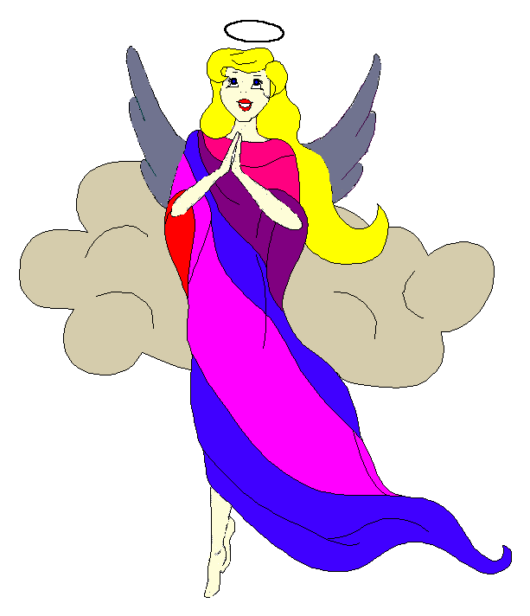
Pow-Wow Date: Tuesday, April 20, 2004

Tribe Members Present
Little Princesses Big Braves
Jamie, Little Cub Lee, Gray Wolf
Logan, Running Reindeer Grant, Gray Fox, Chief
Christine, Little Bird Rob, Early Bird, Wampum Bearer
Kimberly, Rainbow Pony Lee, Soaring Eagle
Alison, Purring Cat Steve, Barking Dog
Haley, Gray Bunny Keith, Injun Mo, Tally Keeper
Emily, Crafty Kitten Darren, Hunting Dog
Pippa, Fast White Pony Jay, Black Hawk
Alexis, Little Acorn Ed, Tall Oak, Sachem
Joanna, Rainbow Dear Randy, Roaring Thunder

Opening
At the time of the great sun beginning to fall under a warm and clear sky, the very unenthusiastic Flying Angels were welcomed into the teepee of Rainbow Dear and Roaring Thunder. The tenth meeting of the Flying Angels was kicked off when Rainbow Dear gave 12 pounding beats of the tribal tom-tom.

The tribe then formed the unbroken circle and chanted the aims, pledge, and slogan led by our fearless Chief.

Wampum Earning ($10):
All princesses clearly and loudly introduced themselves and the big braves. Then each princess announced her efforts that earned wampum for the tribe. Then Injun Mo read the minutes from the March 16th Pow-Wow to the very attentive tribe.

Feather Earning:
- Gray Bunny and Injun Mo prepared a great Jamaican pork chop dinner for Mrs. Mo and for this both earned orange feathers.
- Purring Cat and Barking Dog showed their dream catcher, shark tooth sifter, and bird house that they made together and for this they both earned the first green feather to be awarded in the tribe.
- Fast White Pony very courageously recited the recited pledge and earned a turquoise feather.
- Rainbow Dear and Roaring Thunder showed their sun catcher, picture frame, and race car that they made together and both also earned green feathers.

Meeting Activities:
- Craft | The princesses made door hangers using glitter, letters, numbers, and butterflies provided by Rainbow Dear and Roaring Thunder.
- Snack | Rainbow Dear and Roaring Thunder provided chocolate chip cookies , brownies, chips, dip and lemonade for all the princesses and braves to enjoy.
- Song | None
- Story | Black Hawk told an authentic Indian story about how the rabbit fooled the wolf. This story taught the princesses that you can’t believe everything you hear. In other words…don’t be gullible.
- Trick | Early Bird demonstrated how air flows around a moving object by lining up bottles and placing a lit candle on one end. The princesses would stand on the other end and blow as hard as they could and watch the candle go out.
- Discussions | None

Closing:
All Flying Angels then stood in a circle and the closing prayer was led by the mighty Chief Gray Fox. The Flying Angels then fluttered away into the night until the last Pow-Wow to be held at the Spring Outing on the 1st day in the month of sun and fun.

So went the tenth meeting of the Flying Angels as reported by Injun Mo, Tallykeeper.

Note From The Tallykeeper
This is probably the last Tallykeeper’s report of the year and I have thoroughly enjoyed keeping the minutes of every meeting. I have to say that I’m very impressed with how the princesses have conducted themselves at each meeting and the respect and kindness that they have showed each other throughout the year. This is truly a special tribe and I look forward to the experiences we’ll have as a second year tribe. I know it is time to give up this office because I am completely out of new and interesting ways to describe the meetings and only hope the new Tallykeeper has as much fun as I have had with this office.

