Flying Angels
YMCA Indian Princesses – 3rd Year Tribe

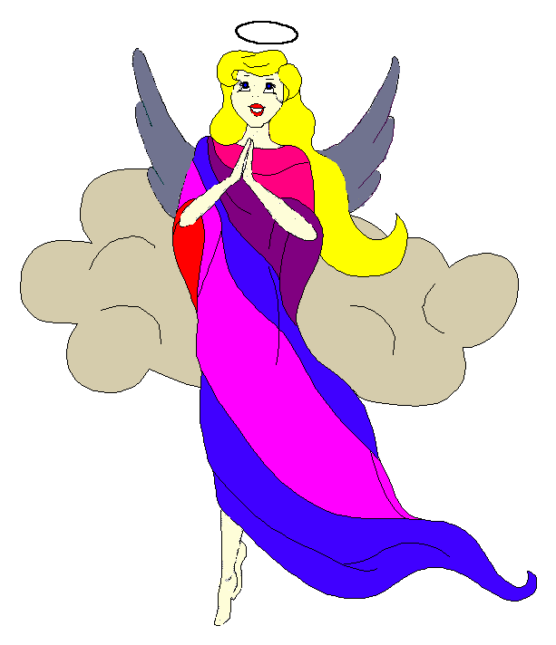
Pow-Wow Date: Tuesday, October 11, 2005

Tribe Members Present

Little Princesses Big Braves
Alexis, Little Acorn Ed, Tall Oak
Jamie, Little Cub Lee, Gray Wolf
Haley, Gray Bunny Keith, Injun Mo
Christine, Little Bird Rob, Early Bird
Kimberly, Rainbow Pony Lee, Soaring Eagle
Alison, Purring Cat Steve, Barking Dog
Logan, Running Reindeer Grant, Gray Fox, Sachem
Meredith, Howling Wolf Gregory, Rising Moon, Chief
Pippa, Fast White Pony Jay, Black Hawk, Tally Keeper
Emily, Crafty Kitten Darren, Hunting Dog, Wampum Bearer

Opening
At the time of the great sun beginning to fall under a balmy sky worthy of enthusiastic planning for a camping trip, the Flying Angels were welcomed with all members in attendance into the teepee of Little Cub and Gray Wolf. The third meeting of this third season of the Flying Angels was kicked off when Little Cub gave 12 pounding beats of the tribal tom-tom.

The tribe then formed the unbroken circle and chanted the aims, pledge, and slogan led by our fearless Chief.

Wampum Earning:
All princesses clearly and loudly introduced themselves and the big braves. Then each princess announced her efforts that earned wampum for the tribe.

Feather Earning:
Since our feather earning this year is based on community service projects, our fearless Chief had previously issued a “Chief’s Challenge” to the Princesses to think of a worthy service project for our tribe. At our meeting, all of the Princesses took turns reading their suggestions for service projects. We will choose the top three projects, which the Flying Angels will then work together to complete.

Meeting Activities:
- Craft | The princesses made torches for use during the ceremonies to be held at our upcoming Camp Kanata trip. The Princesses did a great job in this “hardware project”.
- Snack | Little Cub and Gray Wolf provided nutritious refreshments for all of the princesses and braves to enjoy.
- Song | Running Reindeer and Gray Fox led the Flying Angels in a song that they wrote called “Take me out to the campground”, which was set to the tune of “Take me out to the ballgame.”
- Story | No story was told at this meeting.
- Trick | Tall Oak demonstrated a coin trick in which he made a quarter vanish from one hand and appear in the other.
- Discussions | None

Closing:
All Flying Angels then stood in a circle and the closing prayer was led by the mighty Chief Rising Moon. The Flying Angels then fluttered away into the night until the next Pow-Wow to be held at the Tee-Pee of Rainbow Pony and Soaring Eagle on Tuesday, November 8th.

So went the third meeting of the Flying Angels as reported by Black Hawk, Tallykeeper.

