Flying Angels
YMCA Indian Programs – 1st Year Tribe

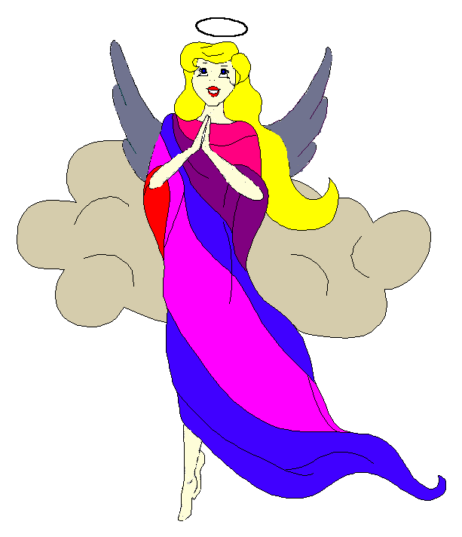
Pow-Wow Date: Tuesday, October 14, 2003

Tribe Members Present
Little Princesses Big Braves
Jamie, Little Cub Lee, Gray Wolf
Logan, Running Reindeer Grant, Gray Fox, Chief
Joanna, Rainbow Deer Randy, Roaring Thunder
Christine, Little Bird Rob, Early Bird, Wampum Bearer
Kimberly, Rainbow Pony Lee, Soaring Eagle
Alison, Purring Cat Steve, Barking Dog
Haley, Gray Bunny Keith, Injun Mo, Tally Keeper
Emily, Crafty Kitten Darren, Hunting Dog
Alexis, Little Acorn Ed, Tall Oak, Sachem

Opening
At the time of the falling sun under a cloudy sky with falling water the extremely eager and giggly Flying Angels were welcomed into the teepee of Gray Wolf and Little Cub. Little Cub was roaring with enthusiasm and kicked off the first ever Pow-Wow of the Flying Angels with 12 beats of the tribal tom-tom. The Flying Angels then raised their hands in praise of the Great Spirit and followed Chief Gray Fox in the tribal prayer. All the braves and princesses then formed the unbroken circle and chanted the aims and pledge lead by our fearless Chief.

Wampum Earning ($0):
The mighty impressive Early Bird explained the idea of Wampum and provided examples of how Wampum is earned by all the braves. At each tribal meeting Early Bird and Little Bird will collect all the Wampum earned by the braves. Early Bird and Little Bird will guard the Wampum to keep it safe so that it can be used by the tribe for good and kind services.

Tribe Name
Since it was the tribe’s initial gathering it had no name. Chief Gray Fox presented three tribe names for the little princesses to vote on by flapping their tale feathers. The names were Dancing Moon, Crazy Cats, and Flying Angels. Five out of nine tales feathers flapped excitedly for Flying Angels so it was at that moment the best Y-Princesses tribe in the great valley of North Carolina was formed.

Feather Earning:
The powerful and mighty Tall Oak explained the earning of feathers. There are 7 beautiful colors and each tribal member’s goal is to earn them all so that they can acquire the most powerful and impressive of all awards before the seasons change to summer.….the great arrowhead.

Meeting Activities:
- Craft | The princesses decorated tribal nametags that were generously provided by Gray Wolf and Little Cub.
- Snack | Gray Wolf and Little Cub provide delicious popcorn and juice for all Flying Angels to enjoy.
- Song | Our great leader Grey Fox and Running Reindeer led us in singing "Friendship Always”. The princesses’ voices suddenly got quieter than they had been all Pow-Wow. It must have been the delicious popcorn that caused them to become parched and unable to sing loudly.
- Story | None
- Trick | None
- Discussions | It was discussed that the Fall camping trip will take place on the 1st day in the Month of giving thanks. The exact location will be determined.

Closing:
Beads and Bear Claws were impressively explained by Injun Mo and then the red crow beads were distributed by Gray Bunny. All Flying Angels then stood in a circle and the closing prayer was led by the mighty chief Gray Wolf. The Flying Angels then fluttered away into the night until the next Pow-Wow to be held at the Tee Pee of Early Bird and Little Bird on the 28th day in the Month of ghost and goblins.

So went the first meeting of the Flying Angels as reported by Injun Mo, Tallykeeper.

