Flying Angels
YMCA Indian Programs – 1st Year Tribe

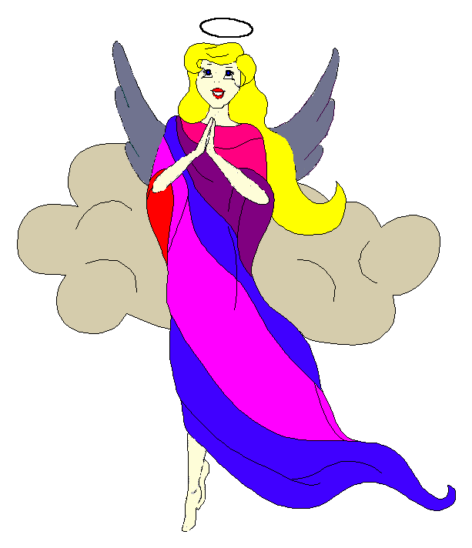
Pow-Wow Date: Tuesday, October 28, 2003

Tribe Members Present
Little Princesses Big Braves
Jamie, Little Cub Lee, Gray Wolf
Logan, Running Reindeer Grant, Gray Fox, Chief
Christine, Little Bird Rob, Early Bird, Wampum Bearer
Kimberly, Rainbow Pony Lee, Soaring Eagle
Alison, Purring Cat Steve, Barking Dog
Haley, Gray Bunny Keith, Injun Mo, Tally Keeper
Emily, Crafty Kitten Darren, Hunting Dog
Alexis, Little Acorn Ed, Tall Oak, Sachem

Opening
At the time of great darkness under a cloudy sky with falling water the tremendously enthusiastic Flying Angels were welcomed into the teepee of Early Bird and Little Bird. The second meeting of the Flying Angels was started in the most perfect way when Little Bird gave 12 pounding beats of the tribal tom-tom. The Flying Angels then raised their hands in praise of the Great Spirit and followed Chief Gray Fox in the tribal prayer. All the braves and princesses then formed the unbroken circle and chanted the aims and pledge lead by our fearless Chief. Injun Mo then read the minutes from the last Pow-Wow to the very attentive tribe.

Wampum Earning ($7):
All princesses flawlessly introduced themselves and the big braves while Gray Bunny distributed the red crow beads. Each princes then announced their efforts that earned wampum for the tribe.

Feather Earning:
Little Cub then stood before the tribe and flawlessly recited the pledge. For her fearless efforts she earned a most impressive turquoise feather.

Meeting Activities:
- Craft | The princesses decorated picture frames with wooden shapes symbolizing fall and Halloween. They also glued on cloth and beads. This ingenious craft was provided by Early Bird and Little Bird and can be used by the tribal members to display pictures that are taken of the tribe throughout the seasons. While the princesses completed the frames the big braves discussed the upcoming camping trip and made final plans.
- Snack | Early Bird and Little Bird provided yummy Halloween cookies, pretzels, juice, milk, and water for all of the tribe to enjoy.
- Song | Rainbow Pony and Soaring Eagle led the tribe in singing "The More We Get Together”. The little princesses especially like this one because the tribe had to sit down or stand up every time the word “together” was mentioned in the song. They thought it was funny to see the big braves look so silly.
- Story | None

- Trick | Tall Oak baffled the tribe with a disappearing penny trick. None of the determined princesses could determine which hand the penny would appear in next. Tall Oak also demonstrated his magic powers by letting the little princesses pick a card from a full deck, return the card to the deck, thoroughly shuffle the cards, and then reveal the card they had just picked. This trick even baffled the big braves.
- Discussions | Final plans were made for the tribal camping trip coming up on Saturday, the 1st day in the Month of giving thanks at Jordan Lake.

Closing:
All Flying Angels then stood in a circle and the closing prayer was led by the mighty Chief Gray Fox. The Flying Angels then fluttered away into the night until the next Pow-Wow to be held at the Tee Pee of Running Reindeer and Gray Fox on the 11th day in the Month of giving thanks.

So went the second meeting of the Flying Angels as reported by Injun Mo, Tallykeeper.

