Flying Angels
YMCA Indian Programs – 1st Year Tribe

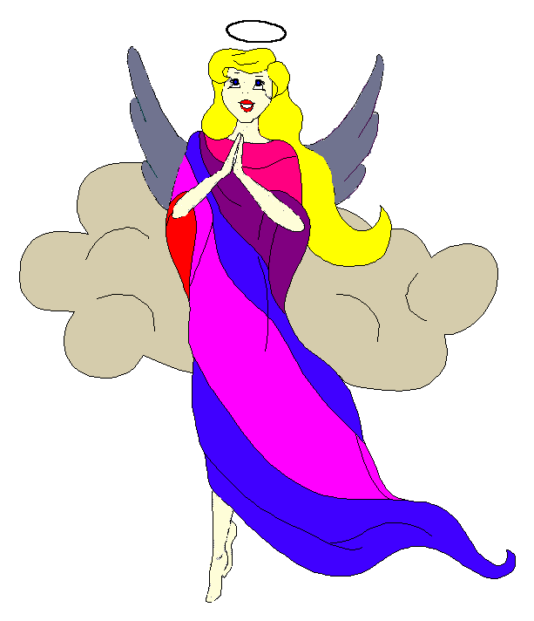
Pow-Wow Date: Tuesday, November 11, 2003

Tribe Members Present
Little Princesses Big Braves
Jamie, Little Cub Lee, Gray Wolf
Logan, Running Reindeer Grant, Gray Fox, Chief
Joanna, Rainbow Deer Randy, Roaring Thunder
Alison, Purring Cat Steve, Barking Dog
Haley, Gray Bunny Keith, Injun Mo, Tally Keeper
Emily, Crafty Kitten Darren, Hunting Dog
Alexis, Little Acorn Ed, Tall Oak, Sachem

Opening
At the time of great darkness under a clear sky with a full moon, the tremendously enthusiastic Flying Angels were welcomed into the teepee of Running Reindeer and Gray Fox. The third meeting of the Flying Angels was started in the most perfect way when Little Cub gave 12 pounding beats of the tribal tom-tom or in this case tribal Tupperware.

Wampum Earning ($6):
All princesses flawlessly introduced themselves and the big braves. Then each princess announced her efforts that earned wampum for the tribe.

All the braves and princesses then formed the unbroken circle and chanted the aims, pledge, and slogan lead by our fearless Chief. We then decide to do the craft since glue was involved and needed to dry before the tribe dispersed into the night.

After the craft Injun Mo read the minutes from the last Pow-Wow, Campout, and fall outing to the very attentive tribe.

Feather Earning:
All the tribal members were distributed a white feather and a yellow feather for completing the 2-mile walk and the campout. Grey Bunny was distributed a blue feather for reciting the 12 aims at the campout.

Running Reindeer stood before the tribe and clearly stated all the names of the tribal members. For this she earned a red feather.
Crafty Kitten recited the six aims perfectly and earned a blue feather.
Little Acorn was inspired by such courage and decided to try and name all tribal members. After much concentration she succeeded and for her courage she also earned a red feather.

Meeting Activities:
- Craft | The princesses made pinecone turkeys and decorated them with colorful feathers to be used as centerpieces at the thanksgiving table. This ingenious craft was provided by Running Reindeer Cub and Grey Fox and can be used as centerpieces by the tribal members at their thanksgiving table. While the princesses completed the turkeys, the big braves discussed the upcoming outing to Disney on Ice.
- Snack | Running Reindeer and Grey Fox provided yummy Chocolate Chip Cookies, Brownies, Popcorn, and juice for all of the tribe to enjoy.
- Song | Barking Dog and Purring Cat led the tribe in singing "BINGO”. For this they provided drums and tom-toms for all the princesses to beat. They also led the tribe in singing friendship always.
- Story | None

- Trick | Roaring Thunder baffled the tribe with an explanation of high and low pressure. He demonstrated the idea by heating a coke can and quickly dipping it in ice water, which crushed the can. All the princesses were amazed even though his trick didn’t work the first time.
- Discussions | None

Closing:
All Flying Angels then stood in a circle and the closing prayer was led by the mighty Chief Gray Fox. The Flying Angels then fluttered away into the night until the next Pow-Wow to be held at the Tee Pee of Soaring Eagle and Rainbow Pony on the 9th day in the Month of many gifts.

So went the Third meeting of the Flying Angels as reported by Injun Mo, Tallykeeper.

