Flying Angels
YMCA Indian Princesses – 3rd Year Tribe

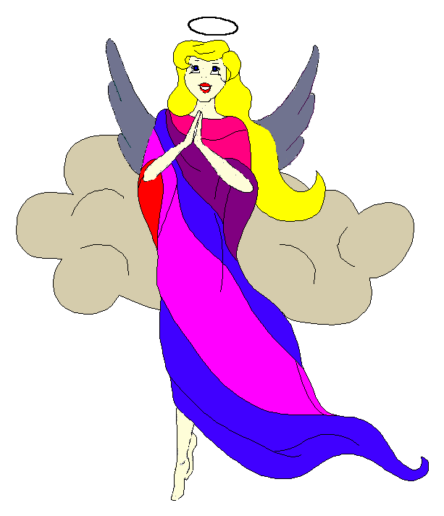
Pow-Wow Date: Tuesday, March 14, 2006

Tribe Members Present

Little Princesses Big Braves
Alexis, Little Acorn Ed, Tall Oak
Jamie, Little Cub Lee, Gray Wolf
Haley, Gray Bunny Keith, Injun Mo
Christine, Little Bird Rob, Early Bird
Meredith, Howling Wolf Greg, Rising Moon
Kimberly, Rainbow Pony Lee, Soaring Eagle
Alison, Purring Cat Steve, Barking Dog
Logan, Running Reindeer Grant, Gray Fox, Sachem
Pippa, Fast White Pony Jay, Black Hawk, Tally Keeper
Emily, Crafty Kitten Darren, Hunting Dog, Wampum Bearer

Opening
As Spring-time approached, the Flying Angels were welcomed into the teepee of Grey Fox and Running Reindeer. The eighth meeting of this third season of the Flying Angels was kicked off when Running Reindeer gave 12 pounding beats of the tribal tom-tom.

The tribe then formed the unbroken circle and chanted the aims, pledge, and slogan led by our fearless Chief, Rising Moon.

Wampum Earning:
All princesses clearly and loudly introduced themselves and the big braves. Then each princess announced her efforts that earned wampum for the tribe. Black Hawk read the minutes of our February 21st meeting to the very attentive Princesses.

Feather Earning:
Our next service project toward earning our third year feathers will take place on Saturday, May 13th at Bond Park for the annual clean-up.

Meeting Activities:
- Craft | The princesses wrote letters to groups of soldiers in Iraq and decorated them with pictures; and made St. Patrick’s Day hats.
- Snack | Grey Fox and Running Reindeer provided wonderful brownies, chips and sodas for all of the princesses and braves to enjoy.
- Discussions | Spring Campout coming up on April 21-23!!!

Closing:
All Flying Angels then stood in a circle and the closing prayer was led by our mighty Chief, Rising Moon. The Flying Angels then fluttered away into the night until the next Pow-Wow to be held at the Tee-Pee of Grey Bunny and Injun Mo on Tuesday, April 11th.

So went the eighth meeting of the Flying Angels as reported by Black Hawk, Tallykeeper.

