Flying Angels
2004-2005 YMCA Indian Programs – 2nd Year Tribe

Pow-Wow Date: Tuesday, September 21, 2004

Tribe Members Present
Little Princesses Big Braves
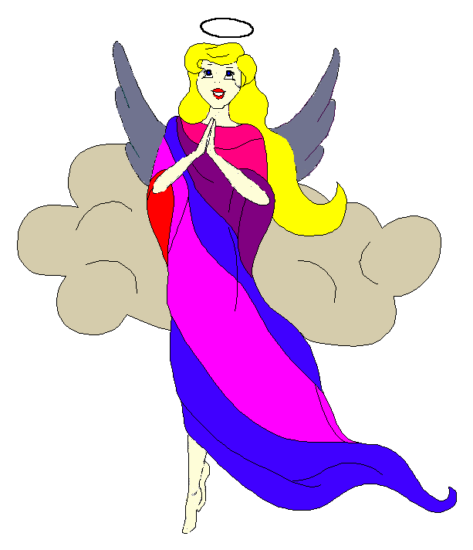
Fast White Pony (Pippa) Black Hawk (Jay) - Chief
Running Reindeer (Logan) Gray Fox (Grant)
Little Cub (Jamie) Gray Wolf (Lee)
Little Acorn (Alexis) Tall Oak (Ed) - Wampum Bearer
Rainbow Pony (Kimberly) Soaring Eagle (Lee) - Sachem
Crafty Kitten (Emily) Hunting Dog (Darren)
Gray Bunny (Haley) Injun Mo (Keith)
Purring Cat (Alison) Barking Dog (Steve) - Tally Keeper
Rainbow Deer (Joanna) Roaring Thunder (Randy)

Opening
On a cool night at the end of the warm summer, the excited Flying Angels were gathered once again into the teepee of Fast White Pony and Black Hawk. The first meeting of our 2nd year began when Fast White Pony sounded 12 beats on the tribal tom-tom.

The tribe then formed the unbroken circle and chanted the aims, pledge, and slogan lead by our fearless Chief. We were all proud of how well we remembered these tribal rites.

Names and Wampum
All princesses then clearly and loudly introduced themselves and the big braves. Each princess announced her efforts that earned wampum for the tribe.

Reading of the Minutes
Barking Dog then recalled the efforts of the Big Braves during their earlier braves only meetings to organize tribal activities for the upcoming year.

Feather Earning:
- No feathers were earned yet, but surely during the next few months the feather will fly as the princesses and braves work together.

Meeting Activities:
Song | Little Cub and Gray Wolf led the whole tribe in the ancient standard “Friendship Always”. Then the Princesses sang a very sweet but much quieter rendition.
Craft | Black Hawk provided materials to make beaded metal bracelets. All of the princesses worked hard with the tiny beads to select the right colors and patters to create their beautiful jewelry.
Snack | Fast White Pony and Black Hawk provided cupcakes, potato chip and peanuts along with a fruit punch and Gatorade for the tribe to enjoy.
Story | None
Trick | None
Discussions | None
Big Braves Discussions | During the crafts and snacks, the big braves decided who will be the host and lead the activities for the tribe meetings. We also worked out the details of the upcoming camping trip. Black Hawk recorded everyone’s duties and will contact all of the big braves with any final questions.

Closing:
All Flying Angels then stood in a circle and the closing prayer was led by the forceful Chief Black Hawk and the mighty Chief of old Gray Fox. Our silent version was especially well done and the Princesses would impress the entire Indian nation with their memory and dedication to the tribal tradition.

Purring Cat then distributed red crow beads to all the tribe.

The Flying Angels then flew off into the night until the next Pow-Wow to be held at the tee pee of the unknown angel on the 5th day in the Month of Falling Leaves and the Harvest Moon (Oct 5th).

So went the late summer meeting of the Flying Angels as reported by Barking Dog, Tallykeeper.

