Flying Angels
2004-2005 YMCA Indian Programs – 2nd Year Tribe

Pow-Wow Date: Tuesday, October 19, 2004

Tribe Members Present
Little Princesses Big Braves
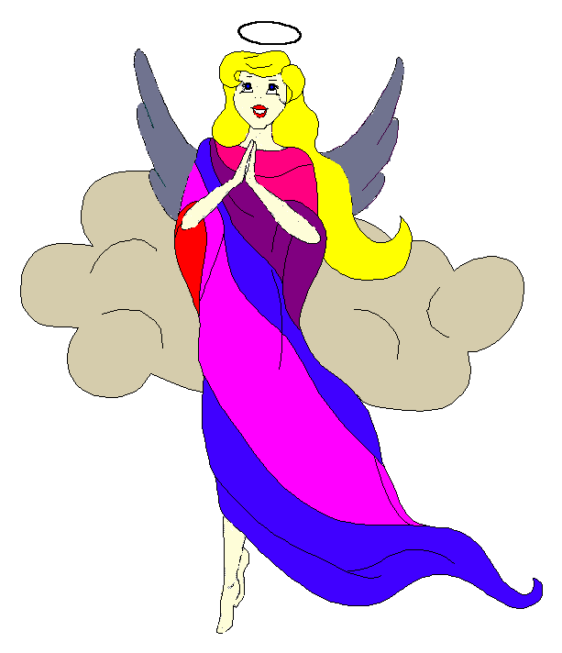
Fast White Pony (Pippa) Black Hawk (Jay) - Chief
Little Cub (Jamie) Gray Wolf (Lee)
Running Reindeer (Logan) Gray Fox (Grant)
Little Bird (Christine) Early Bird (Rob)
Little Acorn (Alexis) Tall Oak (Ed) - Wampum Bearer
Crafty Kitten (Emily) Hunting Dog (Darren)
Gray Bunny (Haley) Injun Mo (Keith)
Purring Cat (Alison) Barking Dog (Steve) - Tally Keeper
Rainbow Deer (Joanna) Roaring Thunder (Randy)

Opening
On a dark and spooky night before Halloween, the Flying Angels gathered at the teepee of Little Acorn and Tall Oak. Thanks to Tall Oak and Little Acorn for hosting our Harvest Moon meeting at the last minute when Soaring Eagle had to cancel because Rainbow Pony was feeling very sick.

The meeting began when Little Acorn rang out 12 hearty beats on the tribal tom-tom.

The tribe then formed the unbroken circle and chanted the aims, the pledge, and our slogan lead by our fearless Chief. There was a little confusion, but the tribe made it through together.

Names and Wampum
All of the princesses then clearly and loudly introduced themselves and their big braves. Each princess also announced her efforts and good deeds that earned wampum for the tribe.
Purring Cat also handed out red crow beads to all the tribe for their attendance at this meeting and the previous meeting.

Feather Earning:
- Since no feathers have yet been earned, Black Hawk reviewed all of the activities that the big braves and princesses can do together to earn their wings. It was agreed that the tribes’ earlier camping trip definitely counted towards a feather.

Meeting Activities:
Song | Purring Cat and Barking Dog lead the tribe in two rounds of “The More We Work Together” standing up or sitting down when the special word was sung. At the end, we were all sitting back where we started.
Craft | For the craft, the princesses put together foam Halloween bracelets with pumpkins and spooky black “Boo’s”. Some of the princess made little orange rings with the extra materials.
Snack | Little Acorn and Tall Oak then set out pretzels, rice krispy treats and cookies for all of the princesses to enjoy. The braves had a good snack too.
Story | None
Trick | Black Hawk then performed a trick that amazed the princess by having a quarter stick to his forehead even when he looked down. Then he showed us all how to do the trick and all of the princesses tried to recreate the magic. Quite a few learned the secret from Black Hawk’s demonstration.
Big Braves Discussions | None

Closing:
All the Flying Angels then stood in a circle and the closing was led by Chief Black Hawk. Our traditional silent version was very well done.

One More Thing:
Before everyone left, Tall Oak took the whole tribe to a spooky tee-pee nearby that was really into the “spirit” of Halloween. Everyone was awed by the number of graves and monsters that were in Little Acorn’s neighborhood. The princesses left prepared for all of the ghouls and goblins that would be out on All Hallows Eve.

The Flying Angels then floated away into the dark and eerie night.

So went the tribal meeting of the Flying Angels during the Moon of Falling Leaves as reported by Barking Dog, Tallykeeper.

