Flying Angels
2004-2005 YMCA Indian Programs – 2nd Year Tribe

Pow-Wow Date: Tuesday, November 9, 2004

Tribe Members Present
Little Princesses Big Braves
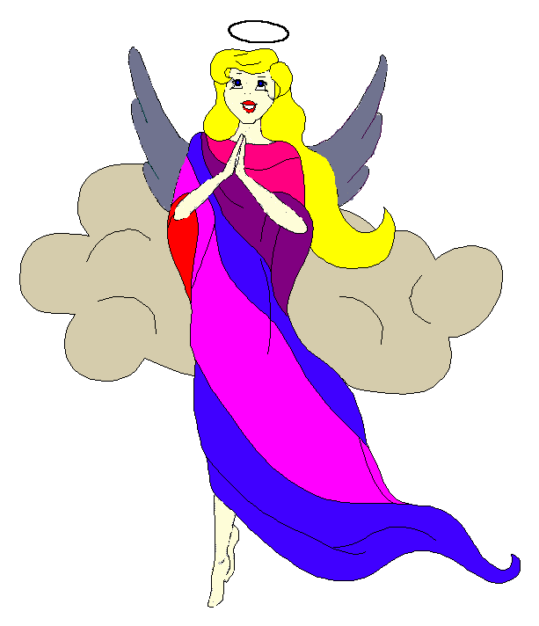
Black Hawk (Jay) - Chief
Little Cub (Jamie) Gray Wolf (Lee)
Running Reindeer (Logan) Gray Fox (Grant)
Little Bird (Christine) Early Bird (Rob)
Little Acorn (Alexis) - Wampum Bearer
Rainbow Pony (Kimberly) Soaring Eagle (Lee) - Sachem
Crafty Kitten (Emily) Hunting Dog (Darren)
Gray Bunny (Haley) Injun Mo (Keith)
Purring Cat (Alison) Barking Dog (Steve) - Tally Keeper
Rainbow Deer (Joanna) Roaring Thunder (Randy)
Howling Wolf (Meredith) Rising Moon (Greg)

Opening
On a cool autumn evening early in the month of the Frost Moon, the Flying Angels gathered at the teepee of Gray Fox and Running Reindeer.

The meeting began when Running Reindeer thumped 12 strong beats on the tribal tom-tom. A new addition to our tribe was present, and we all welcomed Howling Wolf and Rising Moon into our group.

The tribe formed the unbroken circle and chanted the aims, the pledge, and our slogan lead by our host Gray Fox.

Names and Wampum
The princesses then introduced themselves and their big braves. Each princess also announced her efforts and good deeds that earned wampum for the tribe. Purring Cat handed out attendance beads to all the tribe.

Feather Earning:
The talking stick was then passed among the tribe to find out which princess and brave had earned any feathers since the last meeting.
- Little Cub earned the first feathers by confidently and clearly telling us the nine planets in our solar system.
- Rainbow Pony was next and told us how she and her big brave played and coached her soccer team this fall.
- Rainbow Deer also earned a feather for participating with her big brave in the same soccer league as Rainbow Pony.

Congratulations to each princess for their new feathers!

Meeting Activities:
Song | Purring Cat and Barking Dog lead the tribe in singing the Kookaburra song. There was a treat for anyone who laughed loudly during the song, and all of the princesses really earned their gumdrops.
Craft | Gray Fox gave each princess a Christmas shadow box to decorate as the craft. All of the princesses put much effort into decorating their boxes with holiday paints of red, white and green. They all turned out beautifully.
Story | None
Snack | While the paint dried, Gray Fox and Running Reindeer provided popcorn and yummy brownies for the princesses to snack on. We all enjoyed our snack and only crumbs and kernels were left over.
Big Braves Discussions | While the princesses snacked, the brave discussed upcoming tribe activities.
Trick | After the snack, Early Bird showed us his mysteriously appearing quarter illusion. He could make a coin appear under a pitcher of water without moving it. The magic of this trick was all in the lighting.

Closing:
At the end of the meeting, all of the Flying Angels stood in a circle and the closing was led by Chief Black Hawk. Our traditional silent version was very well done.

The Flying Angels then flitted off into the cool evening. We will meet again after turkey day in the teepee of Crafty Kitten and Hunting Don on December 7th.

So went the meeting of the Flying Angels during the Moon of the Great Frost as reported by Barking Dog, Tallykeeper.

