Flying Angels
2004-2005 YMCA Indian Programs – 2nd Year Tribe

Pow-Wow Date: Tuesday, December 7, 2004

Tribe Members Present
Little Princesses Big Braves
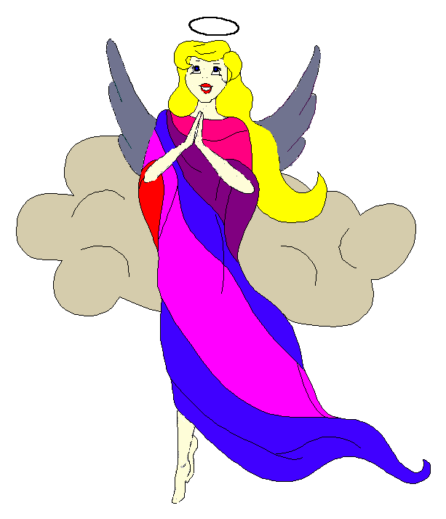
Fast White Pony (Pippa) Black Hawk (Jay) - Chief
Little Cub (Jamie) Gray Wolf (Lee)
Running Reindeer (Logan) Gray Fox (Grant)
Little Bird (Christine) Early Bird (Rob)
Little Acorn (Alexis) Tall Oak (Ed) - Wampum Bearer
Rainbow Pony (Kimberly) Soaring Eagle (Lee) - Sachem
Crafty Kitten (Emily) Hunting Dog (Darren)
Gray Bunny (Haley) Injun Mo (Keith)
Purring Cat (Alison) Barking Dog (Steve) - Tally Keeper
Howling Wolf (Meredith) Rising Moon (Greg)

Opening
On a cold evening early in the month of the Winter Moon, the Flying Angels gathered at the teepee of Hunting Dog and Crafty Kitten.

The meeting began when Crafty Kitten banged out 12 beats on the tribal tom-tom. The tribe formed the unbroken circle and chanted the aims, the pledge, and our slogan.

Names and Wampum
The princesses then introduced themselves and their big braves. Each princess also announced her efforts and good deeds that earned wampum for the tribe. Purring Cat handed out attendance beads to all of the tribe that was present.

Feather Earning:
The talking stick was then passed among the tribe to find out which princess and brave had earned any feathers since the last meeting.
- Feathers were first handed out for everyone’s hike during the Fall Outing at Camp Kanata.
- Little Bird earned her feathers when she displayed and told us about her collection of leaves from local trees.
- Gray Bunny then told us all of the planets in our solar system in order to earn feathers for herself and her big brave.
- Then Purring Cat recited all of the planets including the sun and the asteroid belt both forwards and backwards to earn her feathers.

Congratulations to each princess for their new feathers!

Meeting Activities:
Song | Injun Mo and Gray Bunny led the tribe singing Rudolph the Red Nosed Reindeer with help from their singing Christmas bear.
Craft | Hunting Dog and Crafty Kitten provided the craft which was a soft snowman change purse. All of the princesses assembled and decorated their craft beautifully. The tribal bear claw really came in handy punching out the holes for the snowmen.
Story | None
Snack | While the princesses enjoyed a great snake, the big braves discussed tribal business.
Big Braves Discussions | The braves distributed Winter Inning tickets. We also discussed upcoming holiday activities and decided that we would not do the Cary Town Center Giving Tree event but the tribe would sing Christmas carols at the Carolina House retirement home instead. We decided to meet the on the upcoming Sunday at 1:30pm.
Trick | After the snack, Soaring Eagle showed the tribe a trick by dropping a card into a bucket. The princesses couldn’t do it until Soaring Eagle reveal that the trick was to hold the card flat and let it float down into the bucket.

Closing:
At the end of the meeting, all of the Flying Angels stood in a circle and the closing was led by Chief Black Hawk. Our traditional silent version was very well done.

The Flying Angels then dashed off into the cool evening. We will meet again in the new year in the teepee of Purring Cat and Barking Dog on January 18th.

So went the meeting of the Flying Angels during the Winter Maker Moon as reported by Barking Dog, Tallykeeper.

