Flying Angels
2004-2005 YMCA Indian Programs – 2nd Year Tribe

Pow-Wow Date: Tuesday, January 18, 2005

Tribe Members Present
Little Princesses Big Braves
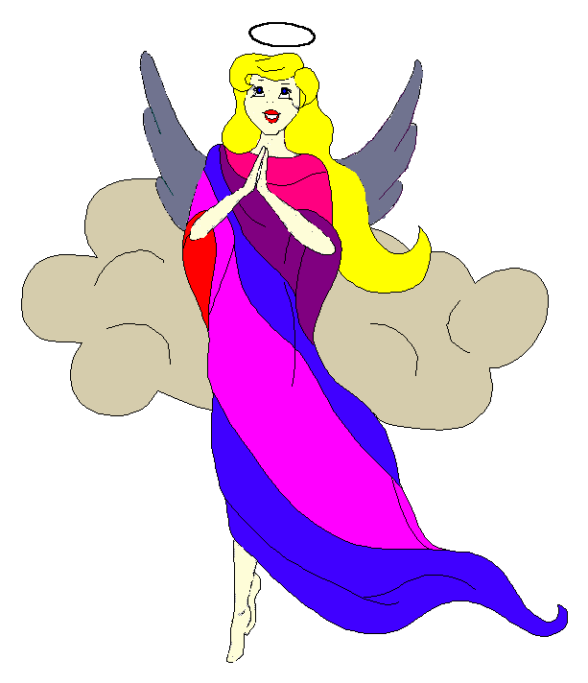
Fast White Pony (Pippa) Black Hawk (Jay) - Chief
Little Cub (Jamie) Gray Wolf (Lee)
Running Reindeer (Logan) Gray Fox (Grant)
Little Bird (Christine) Early Bird (Rob)
Rainbow Pony (Kimberly) Soaring Eagle (Lee) - Sachem
Crafty Kitten (Emily) Hunting Dog (Darren)
Gray Bunny (Haley) Injun Mo (Keith)
Purring Cat (Alison) Barking Dog (Steve) - Tally Keeper
Howling Wolf (Meredith) Rising Moon (Greg)

Opening
On a pleasant evening early in the month of the Great Spirit Moon, the Flying Angels gathered at the teepee of Barking Dog and Purring Cat.

The meeting began when Purring Cat rang out 12 beats on the tribal tom-tom. The tribe formed the unbroken circle and chanted the aims, the pledge, and our slogan.

Names and Wampum
The princesses then introduced themselves and their big braves. Each princess also announced her efforts and good deeds that earned wampum for the tribe. Purring Cat handed out attendance beads to all of the tribe that was present. Purring Cat also handed out bear claws to members who had attended past events.

Feather Earning:
The tall Knobbit talking stick was then passed among the tribe to find out which princess and brave had earned any feathers since the last meeting.
- Feathers were earned by Crafty Kitten and Hunting Dog for making dinner for Mom.
- Kitten and Dog also earned feathers for showing the tribe wild animal tracks that she had observed.
- Gray Bunny and Injun Mo’ earned feathers when she went to work with dad and told the tribe about his job making our water clean.
- Little Bird and Early Bird received their feathers when Little Bird recited the planets in our solar system both forwards and backwards.
- Little Cub and Gray Wolf showed the tribe their family tree poster to earn their feathers.
- Howling Wolf and Rising Moon did an excellent job when Howling Wolf told us all of the planets in our solar system forwards and backwards as well.
- Finally, Fast White pony and Black Hawk recited our nation’s tribal pledge to earn a pair of feathers.

Congratulations to each princess for their new feathers!

Meeting Activities:
Song | Gray Fox and Running Reindeer led the tribe singing a rowdy version of The Hokey Pokey. The Big Braves sang while the Little Princesses put everything from their hands to their butt in the middle and did lots of turn arounds.
Trick | After the song, Gray Wolf challenged the princesses with a balancing trick. All of the girls had to try to pick up a quarter from the floor in front of them but had to keep their feet on the ground and heels against a wall. No one could do it! The trick is that it is impossible to do. The other trick was that Gray Wolf let the princesses keep the quarters anyway.
Craft | Barking Dog and Purring Cat helped everyone make a craft which was a Dutch Christmas heart. The hearts were made of woven construction paper and will be great Valentines Day decorations. The princess worked very hard showed great patience creating their beautiful hearts.
Story | None
Snack | The princesses enjoyed a snack of popcorn and cookies that Purring Cat helped her mother make that day.
Big Braves Discussions | The braves discussed the upcoming Spring Outing at Camp Seafarer and collected deposits to reserve our cabins. We also finished collecting the money to pay for our Christmas gift giving.

Closing:
At the end of the meeting, all of the Flying Angels stood in a circle and the closing was led by Chief Black Hawk. Our traditional silent version was again very well done.

The Flying Angels then wandered off into the chilly evening. We will meet again in the teepee of Rainbow Pony and Soaring Eagle on February 1st (Purring Cat’s birthday).

So went the meeting of the Flying Angels during the Great Spirit Moon as reported by Barking Dog, Tallykeeper.

