Flying Angels
2004-2005 YMCA Indian Programs – 2nd Year Tribe

Pow-Wow Date: Tuesday, February 1, 2005

Tribe Members Present
Little Princesses Big Braves
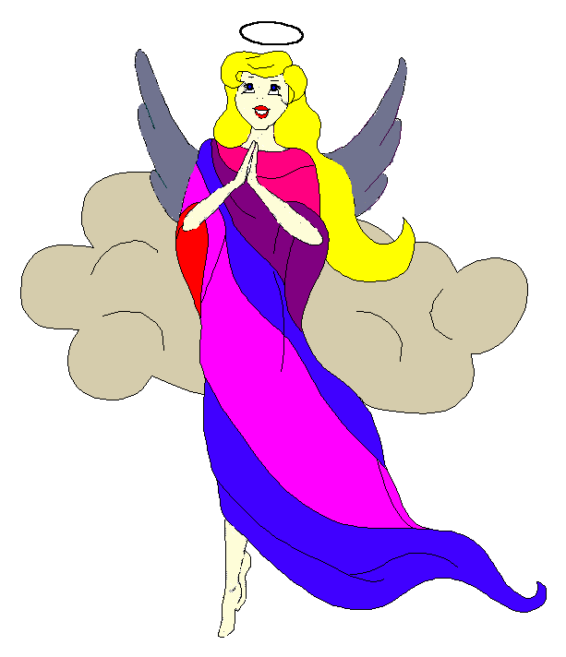
Fast White Pony (Pippa) Black Hawk (Jay) - Chief
Little Cub (Jamie) Gray Wolf (Lee)
Running Reindeer (Logan) Gray Fox (Grant)
Little Bird (Christine) Early Bird (Rob)
Rainbow Pony (Kimberly) Soaring Eagle (Lee) - Sachem
Crafty Kitten (Emily) Hunting Dog (Darren)
Gray Bunny (Haley) Injun Mo (Keith)
Purring Cat (Alison) Barking Dog (Steve) - Tally Keeper
Rainbow Deer (Joanna) Roaring Thunder (Randy)
Howling Wolf (Meredith) Rising Moon (Greg)

Opening
On a chilly evening one the 1st day of the month of the Little Bud Moon, the Flying Angels gathered at the teepee of Soaring Eagle and Rainbow Pony.

The meeting began when Rainbow Pony sounded 12 beats on the tribal tom-tom. The tribe then formed the unbroken circle and chanted the aims, the pledge, and our slogan.

Names and Wampum
Then the princesses introduced themselves and their big braves. Each princess also announced her good deeds that earned wampum for the tribe. Purring Cat handed out attendance beads to all of the tribe that was present.

Feather Earning:
The talking stick was then passed among the tribe to find out which princess and brave had earned feathers since the last meeting.
- Purring Cat earned feathers for preparing dinner for Mom.
- Purring Cat also earned feathers for reporting to the tribe about her day at work with Dad.
- Howling Wolf prepared dinner for Mom earning two feathers and making the tribe very hungry.
- Then Howling Wolf also showed us her rock collection of amethyst, quartz, tiger’s eye, turquoise and a geode to earn two more feathers.
- Rainbow Deer received her feathers for reciting the planets very nicely.
- Little Bird showed the tribe her impressive display of knots to earn two feathers.
- Finally, feathers were earned by Crafty Kitten for telling the tribe about her family’s emergency escape plan.

Congratulations to each princess for their new feathers!

Barking Dog read the Tallykeeper’s report from the last meeting before the fun began.

Meeting Activities:
Song | The tribe sang a round version of Down by the Bay with many verses led by Soaring Eagle. Beside the goose, moose and bears, we even had a giraffe and a platypus to sing about.
Trick | Gray Fox and Running Reindeer then performed a couple of magic tricks that all of the tribe enjoyed. Running Reindeer changed a penny into a dime and Gray Fox showed us how to make cotton balls magically move through the bottoms of his plastic cups. Gray Fox even showed the tribe exactly how he performed his magic.
Craft | The princesses then moved on to work on a craft provided by Soaring Eagle. They made Valentines Day hearts that were filled with sweets and then stitched closed to make beautiful treats for their Moms (or their sweethearts).
Story | None
Snack | The princesses enjoyed a snack of popcorn, nuts and Chex mix. And as a special treat, the tribe sang Happy Birthday to Purring Cat and we all had cupcakes to celebrate.
Big Braves Discussions | The braves discussed the upcoming Spring Outing at Camp Seafarer, the Polar Bear Swim and skating at Jellybeans. We also talked about the tribe’s totem pole that is almost ready to hand out to the princesses to be decorated.  Our newest member, Rising Moon volunteered to host the April 19th meeting and lead the song on April 5th as the last piece of business.

Closing:
At the end of the meeting, all of the Flying Angels stood in a circle and the closing was led by Chief Black Hawk. Our traditional silent version was again very well done.

The Flying Angels then dashed off into the night. We will meet again in the teepee of Little Cub and Gray Wolf on February 15th.

So went the meeting of the Flying Angels during the Moon of the Frost Sparkling in the Sun as reported by Barking Dog, Tallykeeper.

